1. Resources
Original Paper: Gotham Dataset 2025: A Reproducible Large-Scale IoT Network Dataset

Dataset Repository: GothamDataset2025.zip

Paper Repository: GitHub - Gotham Network Packet Labeller

2. Context
This report utilizes the Gotham Dataset 2025, a reproducible and large-scale IoT network dataset generated via the Gotham testbed. The dataset addresses the limitations of existing IoT security datasets by emulating a realistic, heterogeneous smart city environment containing 78 distinct IoT devices (e.g., Air Quality Sensors, IP Cameras, Smart Power Grids) operating on protocols such as MQTT, CoAP, and RTSP.

3. Dataset
The Gotham Dataset 2025 was originally provided in two distinct formats: raw data and processed data. The raw data consisted of network traffic captures in PCAP format, collected via tcpdump and organized by benign and malicious scenarios.

The processed data was supplied as CSV files, derived from the PCAP files using the Tshark feature extraction tool. These CSV files featured a tabular structure where each row represented a network packet, containing a vector of 23 technical features (such as frame length, protocols, IP addresses, and ports) alongside a classification label identifying the traffic as either normal or belonging to one of the 10 different multi-class attack types. This report narrows the scope to a binary classification problem: distinguishing benign traffic from command and control.
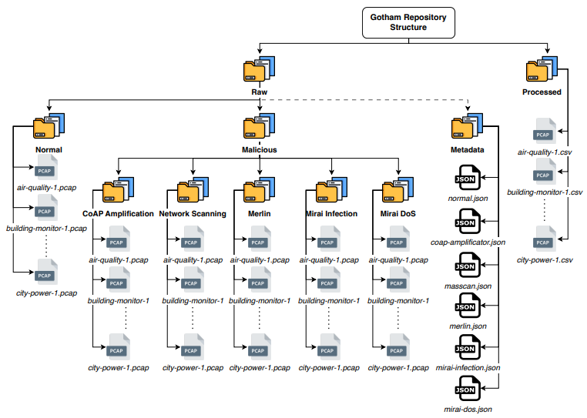

4. Methodology
The implementation is based on the data processing scripts provided in the official repository of the Gotham Dataset 2025 paper.

4.1. Data Acquisition and Sampling Strategy
The dataset was processed using a chunk-based loading strategy (chunksize=100,000). A sampling strategy was applied during the loading phase:
- Malicious Traffic Retention: All instances labeled with "C&C" were retained to preserve critical attack patterns.
- Benign Traffic Downsampling: Only 5% of the instances labeled as benign traffic were randomly sampled.
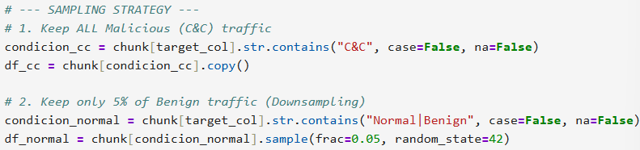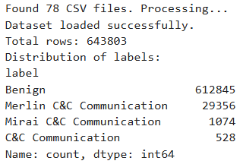

4.2. Preprocessing and Feature Engineering
- Binary Labeling: The multi-class labels were mapped to a binary target variable: 0 for Normal/Benign traffic and 1 for C&C traffic.
- Feature Removal: Crucially, network identifiers that could lead to overfitting were explicitly removed. The dropped features included ip.src, ip.dst, eth.src, eth.dst, and frame.time.
- Encoding and Scaling: Categorical features (such as protocols and flags) were transformed using Label Encoding. Constant columns with zero variance were removed to reduce noise. The feature set was normalized using a Standard Scaler to ensure convergence during training.
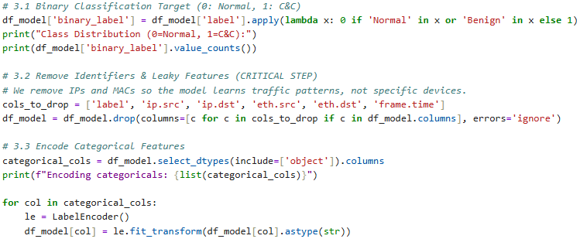
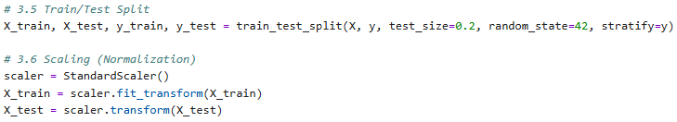
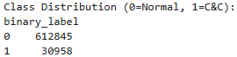
4.3. Model Architectures and Training Setup
Centralized learning:
A Deep Neural Network (DNN) using the TensorFlow/Keras library.
- Input Layer that receives the packet data.
- Hidden Layers (with 64, 32, and 16 neurons) to learn complex patterns.
- Dropout (0.2), which randomly turns off 20% of the neurons during training. This forces the model to learn general patterns instead of just memorizing the data.
- Output Layer uses a "Sigmoid" function, which outputs a probability between 0 and 1 (0 = Normal, 1 = Attack).
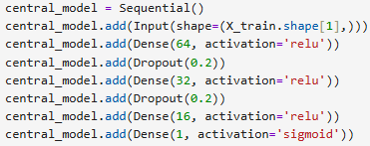
Training: The model saw the entire dataset and trained on it for 10 full cycles (epochs).
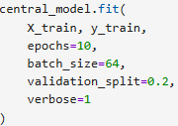

Federated learning:
Simulate 5 separate IoT devices (clients). Data partitioning: training data (X_train) sliced into 5 equal pieces. Each simulated device got one piece.
- Distribution: A central server sends a generic, untrained model to the 5 clients.
- Local Training: Each client trains this model only on its own small slice of data for a short time (1 epoch).
- Aggregation: The clients send only the mathematical updates back to the server.
- Averaging: The server takes these 5 updates and averages them together to create a smarter "Global Model".
- Repetition: Repeated this cycle for 5 rounds to make the model accurate.
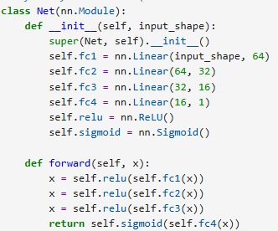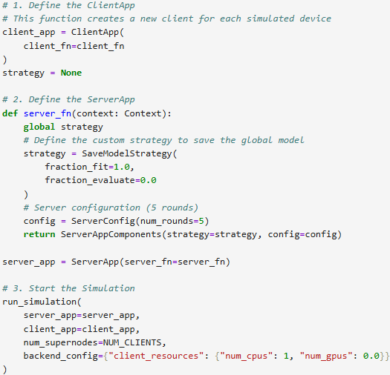

Random Forest:
An ensemble learning method using the RandomForestClassifier.
- Estimators: Composed of 70 separate decision trees (n_estimators=70) working in parallel.
- Constraints: Each tree is limited to a maximum depth of 20 (max_depth=20) to prevent overfitting.
- Balancing: Uses class_weight='balanced' to automatically adjust weights inversely proportional to class frequencies in the input data.
- Features: Considers the square root (sqrt) of the total features when looking for the best split.
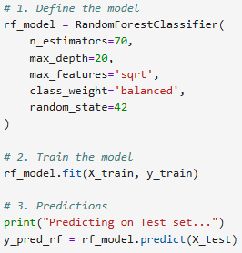

KNN:
A distance-based classifier using the KNeighborsClassifier from the scikit-learn library.
- Neighbors: Configured with K=3 (n_neighbors=3), meaning it looks at the 3 closest data points to decide the class.
- Metric: Relies on standard Euclidean distance to measure similarity between network packets.
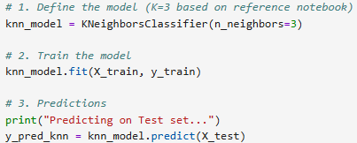

XGBoost:
A Gradient Boosting model using the XGBClassifier library. Based on an ensemble of decision trees built sequentially, where each new tree corrects the errors of the previous ones.
- Optimization: Uses logloss as the evaluation metric to minimize the error in probability predictions.
- Configuration: Uses a fixed random seed (random_state=42) to ensure the tree structure is reproducible.
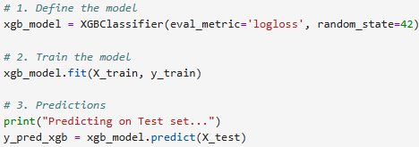

Extra Trees:
An ensemble method using the ExtraTreesClassifier (Extremely Randomized Trees). Unlike Random Forest, this model selects cut-points completely at random for each feature and uses the whole learning sample. Aggregates predictions from a multitude of unpruned decision trees to reduce variance.
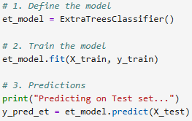

Decision Tree:
A single tree-based model using the DecisionTreeClassifier from scikit-learn. Creates a flowchart-like structure where internal nodes represent tests on attributes and leaf nodes represent class labels.
- Configuration: Uses a fixed random seed (random_state=42) to ensure the tree structure is reproducible.
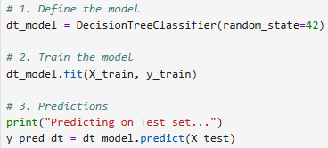

Logistic Regression Model:
A linear classifier using the LogisticRegression algorithm from scikit-learn. Uses the logistic function to model the probability of a packet belonging to a specific class (Normal vs. C&C).
- Solver: Configured with a maximum of 1000 iterations (max_iter=1000) to allow the optimization algorithm sufficient time to converge.
- Configuration: Uses a fixed random seed (random_state=42) to ensure the tree structure is reproducible.
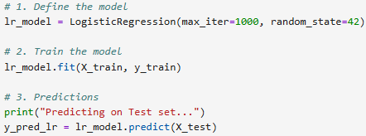

5. Results
Centralized Deep Learning
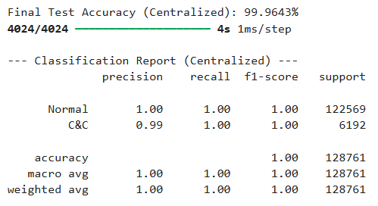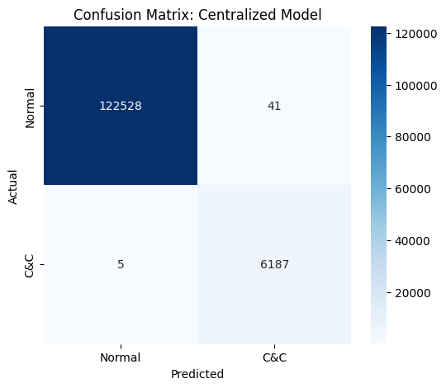

Federated Learning Simulation
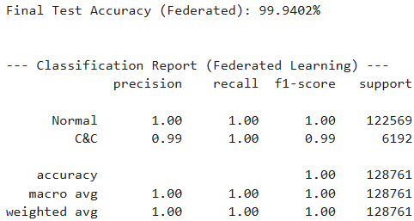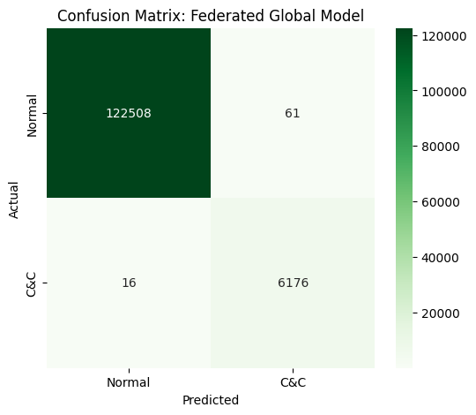

Random Forest
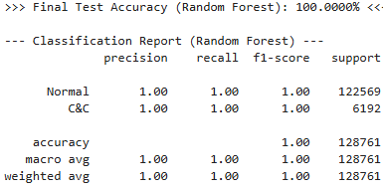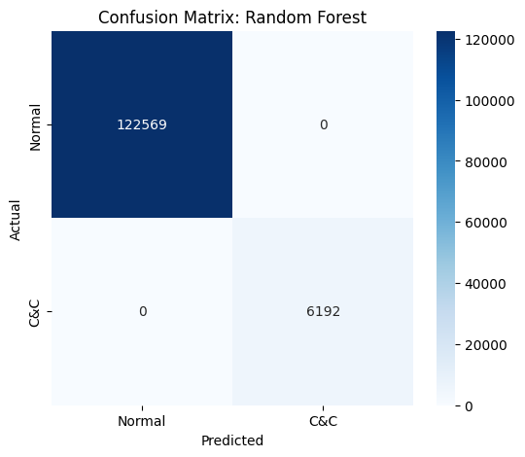
KNN
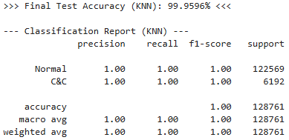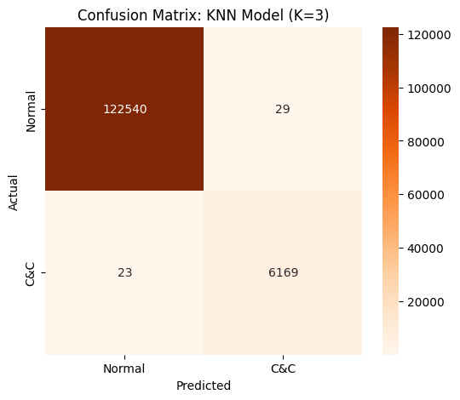

XGBoost
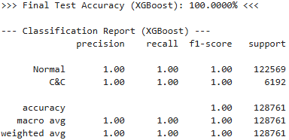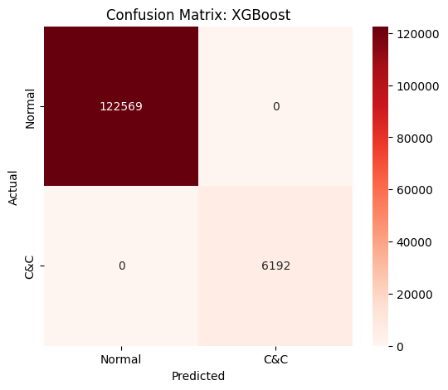

Extra Trees
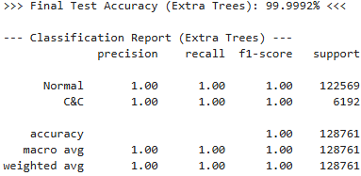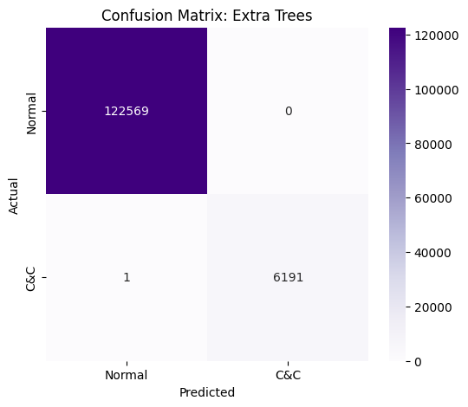
Decision Tree
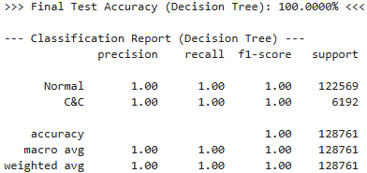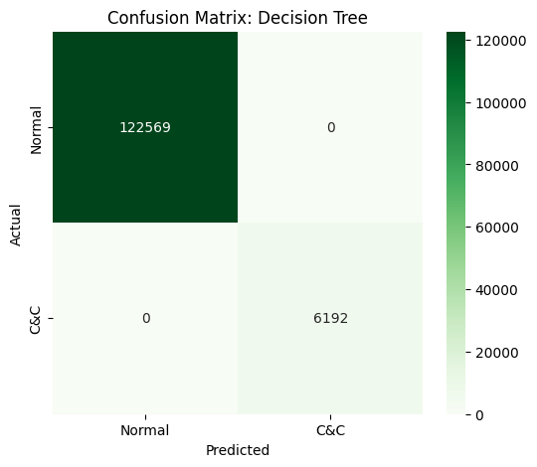

Logistic Regression Model
